Unit 4 - Lesson 5 - Establish Project’s Information Production Methods & Procedures
Lesson 5 of 6
Lesson Objectives
⧉ Audio placeholder (00:09) — no local audio matched this placeholder

Project’s Information Production Methods & Procedures
This explains the ‘How’ of information production. A schedule of methods and procedures to be used on the project which support the following:

Audio transcript (00:54)
This explains the how of information production. The project's information productions methods and procedures can be incorporated into other documentation. They do not need to be standalone. These project information procedures should include 1. Existing information Methods and procedures related to how surveys will be undertaken and how information needs to be captured and who is accountable for their undertaking. 2. New information Methods and procedures related to whether templates need to be used and how approval and authorization procedures are undertaken. 3. Security The security of information how it's distributed. And 4. Delivery The methods and procedures related to configuring information for delivery for use by the appointing party. A common method is to produce diagrams or information delivery manuals mapping out the processes that tend to be very specific to the appointing party.
Source audio: Lesson 5 - Establish Projects Information Production Methods Pro.mp3
As well as the production of information, the methods and procedures should also consider the following:
Checking

Example: Establish the Project's CDE
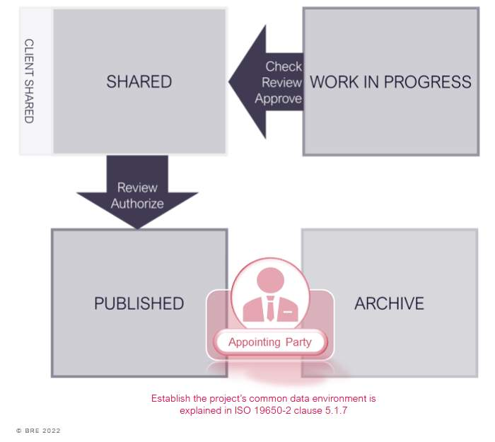

Example: Approval Workflows
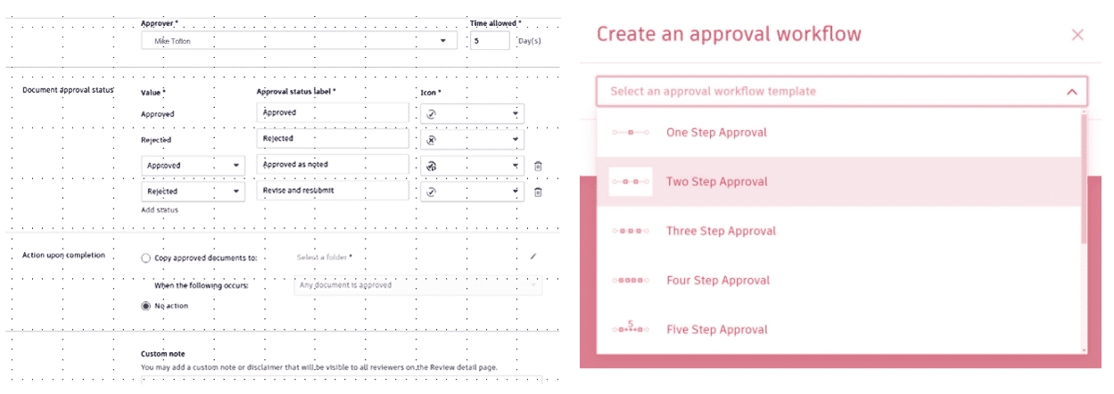
The process may have bespoke approvals, which need to be detailed within the methods and procedures .

Example: Exchanging Sensitive Information
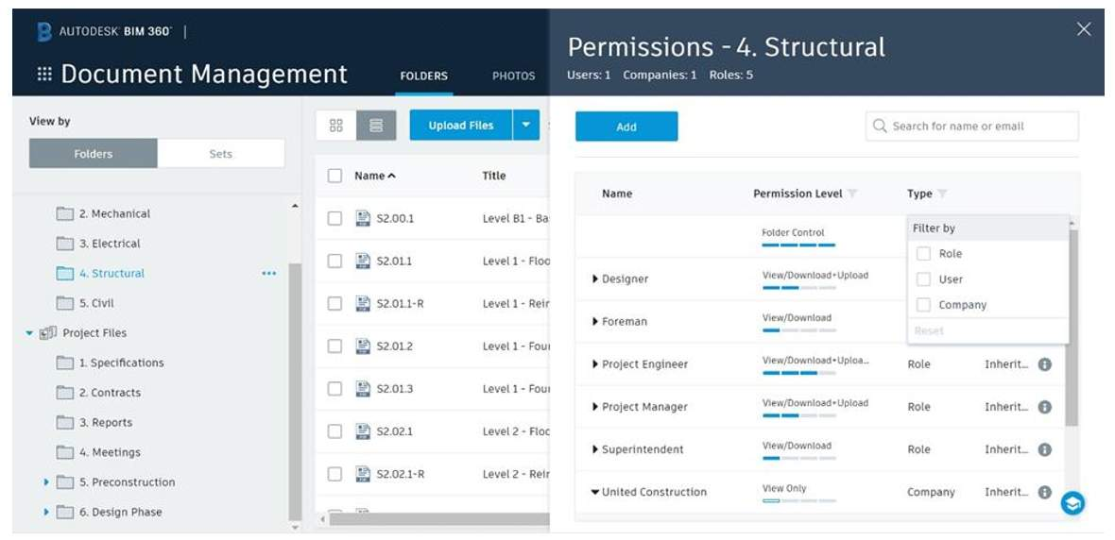
There will almost certainly be custom methods and procedures in relation to the sharing or exchange of information that is deemed as a Sensitive asset. The process may define access permissions, or the introduction of information insecurity codes for example.

Example: Project Mobilization
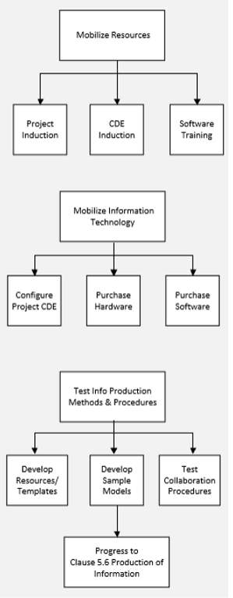

Lesson Summary
Lesson complete! You are now able to:
Understand how a Project's Information Production Methods and Procedures are Established
[CONTINUE]

